Dataflow:

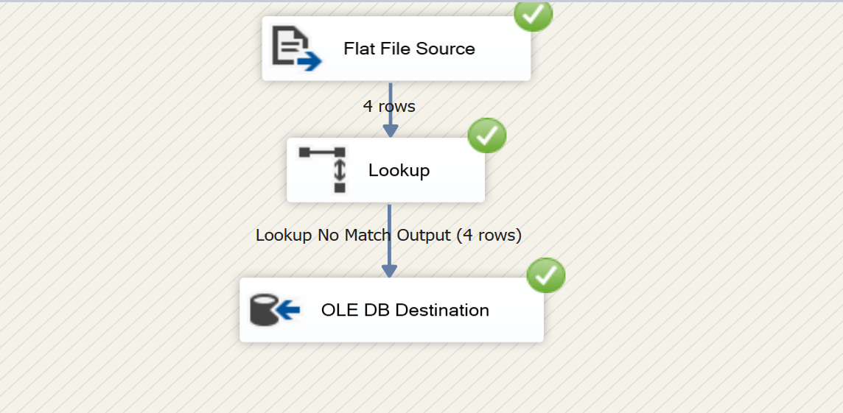

Flat file Source:

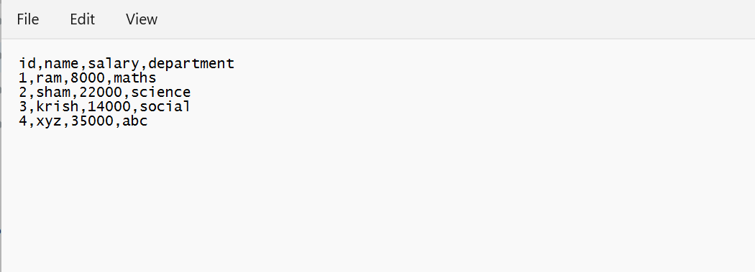

Destination before updating:

Destination after updating:

